**A comprehensive content strategy for enhancing the online presence and authority of the tech company:**

Here’s a structured approach to developing a **comprehensive content strategy** to enhance the online presence and authority of the tech company.

**Comprehensive Content Strategy for Enhancing Online Presence and Authority**

**1. Define Objectives**

* Increase brand awareness in the tech industry.
* Improve search engine rankings (SEO) to attract organic traffic.
* Build thought leadership by publishing authoritative and insightful content.
* Engage and educate the audience about tech trends and innovations.
* Drive conversions by turning readers into potential clients or customers.

**2. Identify the Target Audience**

* Tech professionals, startups, and entrepreneurs looking for innovative solutions.
* Businesses seeking tech partnerships and software solutions.
* Students and tech enthusiasts wanting to stay updated on trends.
* Investors interested in emerging technologies.

**3. Content Pillars (Main Topics of Focus)**

1. **Emerging Technologies** – AI, Blockchain, IoT, Quantum Computing, etc.
2. **Tech Industry Trends & Innovations** – Market shifts, new software, and major disruptions.
3. **Case Studies & Success Stories** – Real-world applications of tech solutions.
4. **Guides & Tutorials** – How-to guides on software, coding, and tech tools.
5. **Opinion Pieces & Thought Leadership** – Expert insights into industry changes.
6. **Interviews & Guest Contributions** – Tech leaders sharing expertise.
7. **Company Updates & Achievements** – Milestones, new services, partnerships.

**4. Content Types**

* **Blog Articles** (1000+ words with SEO optimization).
* **Infographics & Data Visualizations** for complex topics.
* **Video Content** (Webinars, Tutorials, Explainers).
* **Podcasts & Interviews** featuring industry leaders.
* **Social Media Content** (LinkedIn, Twitter, YouTube, Medium).
* **Email Newsletters** for direct audience engagement.

**5. SEO & Keyword Strategy**

* Conduct **keyword research** using tools like Google Keyword Planner & SEMrush.
* Optimize for **long-tail keywords** (e.g., “How AI is transforming businesses in 2025”).
* Use **structured metadata**, internal linking, and backlinks to boost search rankings.
* Create **pillar content** with subtopics to build topic authority.

**6. Publishing & Distribution Strategy**

* **Blog Posting Frequency**: Publish 2-3 articles per week.
* **Social Media Promotion**: Share content on LinkedIn, Twitter, and Reddit.
* **Guest Posting & Backlinks**: Contribute to tech blogs to build credibility.
* **Email Marketing**: Weekly newsletters with curated insights.
* **Community Engagement**: Answer queries on Quora, Reddit, and industry forums.

**7. Performance Measurement & Optimization**

* Track performance using **Google Analytics** and **Search Console**.
* Monitor **engagement metrics** (shares, comments, time on page).
* A/B test different content formats to see what resonates.
* Adjust strategy based on performance data.

**The Rise of Generative AI: How It’s Shaping the Future of Technology**

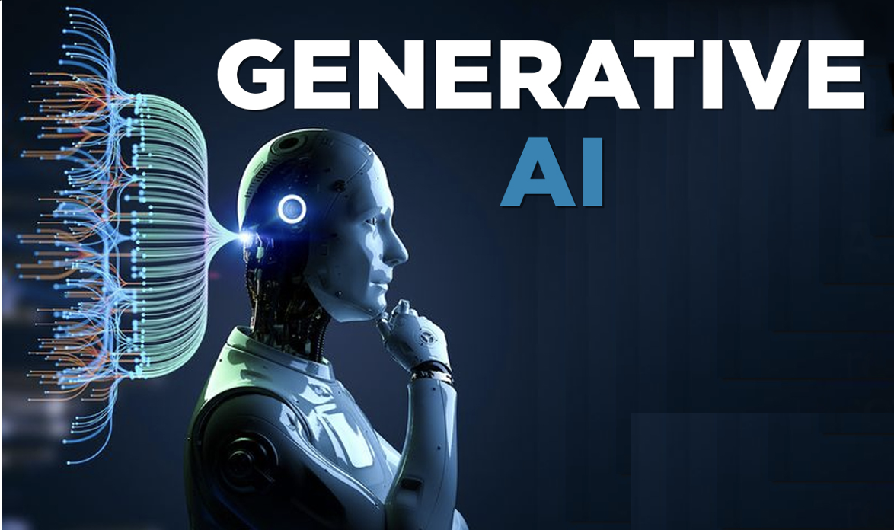

**Introduction**

Artificial Intelligence (AI) has seen significant advancements over the past decade, but 2024 and 2025 have marked a new era with the rapid evolution of **Generative AI**. Tools like **ChatGPT, DALL·E, Midjourney, and Gemini** have transformed industries by generating human-like text, creating stunning visuals, and even composing music.

From **business automation** to **healthcare**, **software development**, and **content creation**, Generative AI is reshaping how we work and interact with technology. But what does the future hold? And how are businesses leveraging this powerful tool? Let’s explore the latest developments in Generative AI and how it is revolutionizing industries.

**What is Generative AI?**

Generative AI leverages large amounts of data, algorithms, and deep learning logics to create, and mimic human endeavors like coding, composing music, and even drafting images and 3D models enables. To elaborate further, Generative AI's foundation is based on deep learning models which scans data, analyze information, and develops new data that is useful.

Popular Generative AI models include:

* **GPT-4 and Gemini** – Text generation
* **DALL·E and Midjourney** – Image creation
* **Runway ML** – AI-powered video editing
* **MusicLM** – AI-generated music

These models have been trained on extensive datasets, allowing them to understand context, emotions, and user intent, making them incredibly powerful for various applications.

**How Generative AI is Transforming Businesses in 2025**

Businesses are adopting Generative AI at an unmatched rate because it makes things more efficient, lowers costs, as well as improves customer satisfaction. A countless number of industries are now using this technology:

A. Generative AI is powerfully enabling a deep revolution in digital marketing as:

*AI can automatically create content for reports, ads and blogs.

*For AI-Powered SEO Optimization, people use tools such as Surfer SEO and Clearscope to help make content better for search engines.

*AI makes engaging posts for social media management, in addition to scheduling posts to achieve maximum effect.

The AI-powered "Imagine" tool from Meta is a new development that automatically generates lots of social media content, which really helps brand engagement.

B. Software development and Coding:

To do things like the following, developers are starting to use AI tools like GitHub Copilot and CodeWhisperer to:

*Write code faster and fix errors faster

*Completely automate each repetitive coding task.

* Find weak spots to improve cybersecurity.

**OpenA**I is developing Codex Pro, which lets all developers create complete apps from any natural language prompts.

C. Healthcare & Drug Discovery:

Generative AI is making many breakthroughs as:

*AI helps to analyze patient data for many personalized treatments in medicine.

*Molecules made by AI make drug discovery faster.

* AI models help doctors use medical imaging and diagnosis to find diseases faster.

**Recent Development:** Google’s **Med-PaLM 2** AI has shown remarkable accuracy in diagnosing diseases, outperforming human doctors in some cases.

D. E-commerce & Customer Service:

Retailers are utilizing AI in e-commerce and customer service to:

*Create descriptions for your products.   
*Customize your buying experiences.

*Boost AI-powered chatbots for round-the-clock client service

What’s the Recent Development?

Amazon is creating AI-powered shopping assistants that offer real-time suggestions.

E. Banking & Finance:

AI is getting better in the following areas: automated financial analysis, fraud detection, and AI-powered investing methods

Recent Development: IndexGPT, an AI-powered tool that provides tailored investment recommendations, was introduced by JPMorgan Chase.

**Ethical Concerns & Challenges of Generative AI**

Despite its advantages, generative AI has drawbacks.

*Deepfakes and Misinformation: Videos and news produced by AI have the potential to disseminate misleading information.   
*Issues with Data Bias and Fairness: AI models may display biases as a result of the training data they use.   
 Some jobs may be replaced by automation, necessitating retraining of the workers.

Solution: To guarantee responsible AI development, governments and tech firms are drafting AI legislation.

**Future Prospects for Generative AI**

In the future, generative AI is anticipated to:

• Strengthen Human-AI Cooperation: AI will support humans, not take their place.   
• Advanced AI Creativity: AI-produced music, art, and films that are more lifelike.   
• Transform education with AI tutors that offer individualized instruction.

Future Trend: SiriGPT, an AI-powered assistant that is significantly more sophisticated than existing voice assistants, is reportedly in development by Apple.

**Conclusion**

Rapid global change is being brought about by generative AI, which is redefining both daily life and industry. Even though there are still moral dilemmas, this technology is among the most important developments of the decade because the advantages greatly exceed the disadvantages.   
Adopting AI-powered solutions will be essential for companies and individuals hoping to stay ahead in the digital era as 2025 approaches. AI's future is in improving human creativity, productivity, and efficiency rather than merely automating tasks.